**Soldering Iron**

|  |  |
| --- | --- |
| Author | Nathan Bruggeman |

Content

1 Introduction 1

2 Material and methods 2

2.1 Material: 2

2.2 Methods: 3

3 Results 4

3.1 Power supply 4

3.1.1 Electrical schematic 4

3.1.2 How does it function? 4

3.2 Regulator 5

3.2.1 Electrical schematic 5

3.2.2 How does it function? 5

3.3 Amplifier 6

3.3.1 Electrical schematic 6

3.3.2 How does it function? 6

3.4 CPU 7

3.4.1 Electrical schematic 7

3.4.2 How does it function? 7

3.5 Display 8

3.5.1 Electrical schematic 8

3.5.2 How does it function? 8

3.6 PCB design 9

3.7 Finalized product 9

4 Discussion 10

5 Reference list 10

# Introduction

This is a paper about a soldering iron. The project comes from the Elektor magazine [1] that is found on Blackboard under "project designs" which contains a step-by-step plan, diagrams and explanations about the soldering iron. The soldering iron is based on this magazine. This device is a professional soldering iron because of the 60vA toroidal transformer with a secondary voltage of 2 x 12v and the Weller RT soldering pin. The soldering iron is able to solder the finest components because the soldering pin is very fine. This is perfect for soldering PCBs. In this application note there is an overview of the components and the methods used and there is a discussion which contains all the problems and the development process of the project.

# Material and methods

## Material:

The soldering iron uses 0805 SMD resistors and capacitors. There are also some THT capacitors. It uses two coils; one choke coil and one common mode choke coil. There are also three diodes of which one is a Zener diode. It also needs five transistors and three ICs. One of these ICs is the 8-bit MCU ATmega4809-PF for controlling most of the components. It also needs a power relay and some pin headers to connect other components if desired. These pin headers are in different pin numbers per pin header. The toroidal transformer that is used for converting an alternating voltage to an alternating voltage with a different value. This concerns a main voltage of 230V that must be converted to a lower value. A primary fuse of 250V by 0,63A is inserted into the 42R Series IEC connector to protect the device. The used fuse is a ceramic slow blow fuse. To show the degrees to which the soldering iron is set, a 4-digit 7-segment display is used, which is controlled with an I²C LED driver (TM1637). The degrees can be set by turning the rotary encoder to the degrees which is needed and the rotary encoder needs to be pressed to set the desired degrees.

The rotary encoder designated by the magazine cannot be used because it does not have a built-in push button. This is replaced by the S-series of this rotary encoder. The two 10-pin box headers, the two 10-pin IDC-plugs and the 10-wire flatcable are not needed in this soldering iron because the display and the rotary encoder are placed in the housing of the soldering iron. They are therefore directly connected on a pin header and on the ATmega. The IEC connector and the GX12 air aviation connector for connecting the soldering iron itself to the PBC print are also connected external. All the external components are fastened in the provided place made in the case itself.

|  |  |  |
| --- | --- | --- |
| **Mouser**  [https://www.mouser.be/] | **TME**  [https://www.tme.eu/be/en/] | **Conrad**  [https://www.conrad.be/] |
| **Price:** 77,88 euro’s | **Price:** 77,44 euro’s | **Price:** 36,42 euro’s |
| **Delivery date:** 23-03-2022 | **Delivery date:** 23-03-2022 | **Delivery date:** 25-03-2022 |
|  |  |  |

## Methods:

To make the project, the correct components must be ordered. Mouser is used for this. Here the datasheets can also be found. Altium Designer is used to design the printed circuit board. The housing of the soldering iron is designed with Fusion 360.

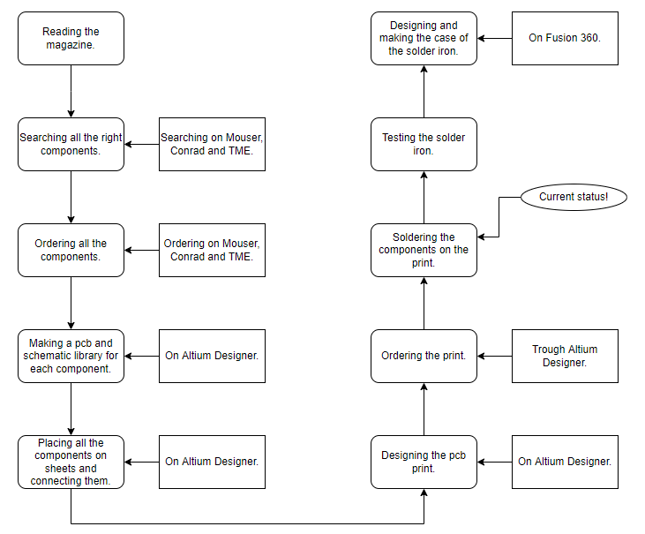

When a project is selected, the correct components must be ordered. Now the PCB and schematic libraries are created for each component. When these have all been created, they must be placed and connected like the diagrams in the magazine. Now the PCBs are designed on Altium Designer so that the printed circuit board can be ordered. When the printed circuit board are ready and available, the soldering of all components on the printed circuit board will start. When this is done, the soldering iron can be tested. If this works, the housing is designed and made.

# Results

## Power supply

### Electrical schematic

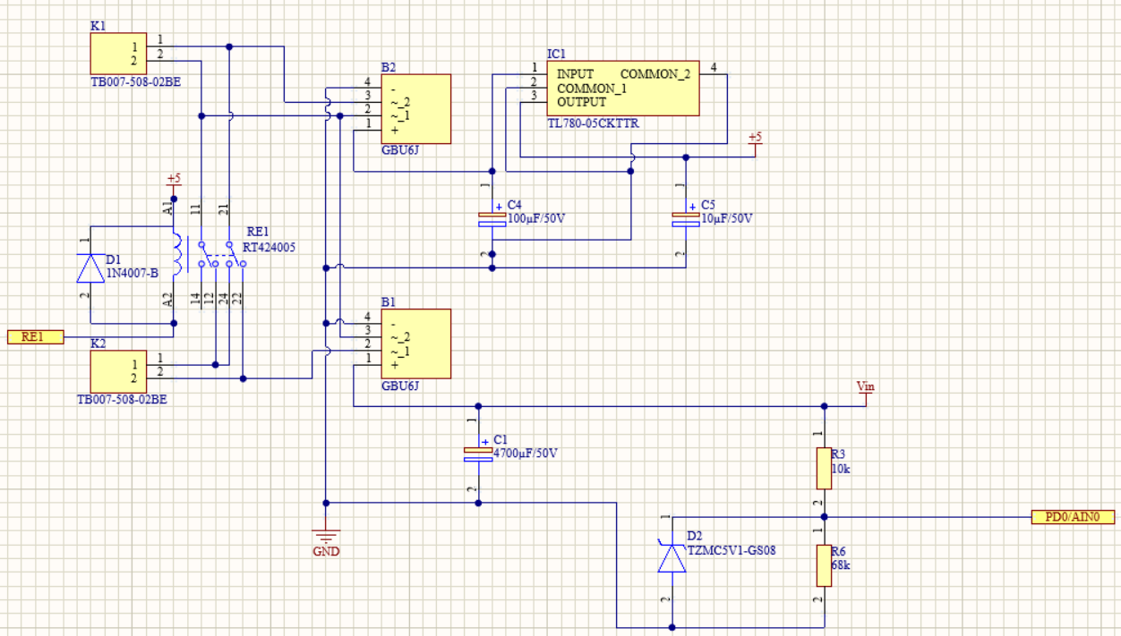

### How does it function?

This is the power supply of the soldering iron. The power cable of the net is inserted to the 42R series connector. In this connector is a A primary fuse of 250V by 0,63A inserted. The soldering iron is fed by one toroidal transformer. In this model the secondary windings are used. One secondary winding is used for the +5V power supply for the logic and control circuits trough the bridge rectifiers and IC1. Zener diode D2 is used as overvoltage protection.

## Regulator

### Electrical schematic

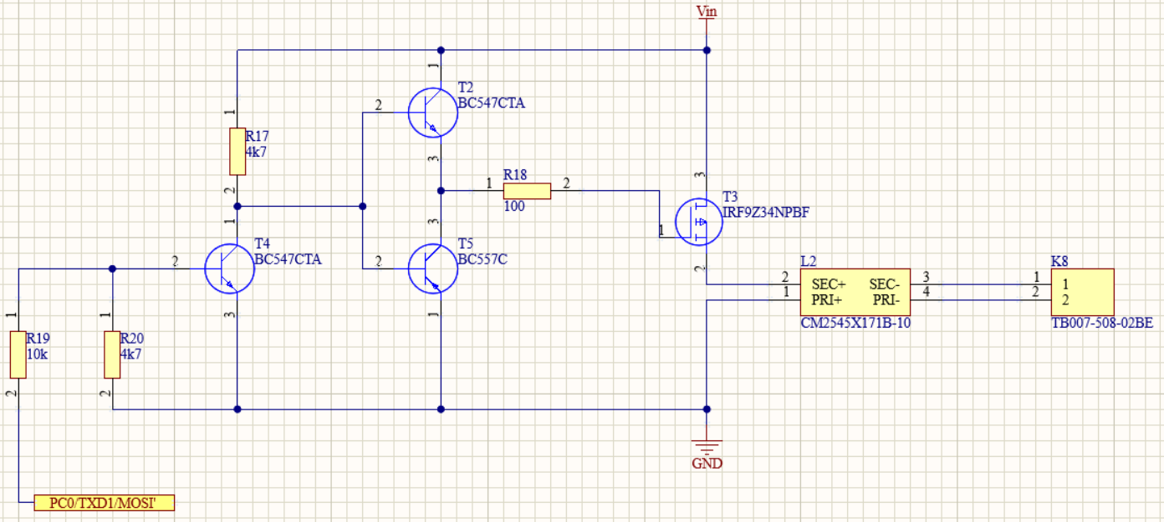

Figuur 1: Schematic regulator

### How does it function?

The temperature of the pin on the soldering iron is PWM-sent by the power controlled by the transistors, T4 and T5, used to regulate electric current. In this circuit a small amount of current flows into the base conductor which controls a larger current between the collector and emitter. Common mode choke L2 suppresses RF interferences on the soldering iron cable. T3 reduces the current (Id) at positive gate-source voltages.

## Amplifier

### Electrical schematic

### How does it function?

Around IC2A and IC2B are opamp circuits that amplify the voltage on the temperature sensor terminal. Without counter-coupling with the very large voltage gain of the opamp, a voltage is created between the inputs that drives the output close to the supply voltage. The counter coupling counteracts this. The output is controlled by the opamp to the point that current flows through R1 and R12 as much as it takes to make the voltage on the inverting input equal to the one on the non-inverting input.

## CPU

### Electrical schematic

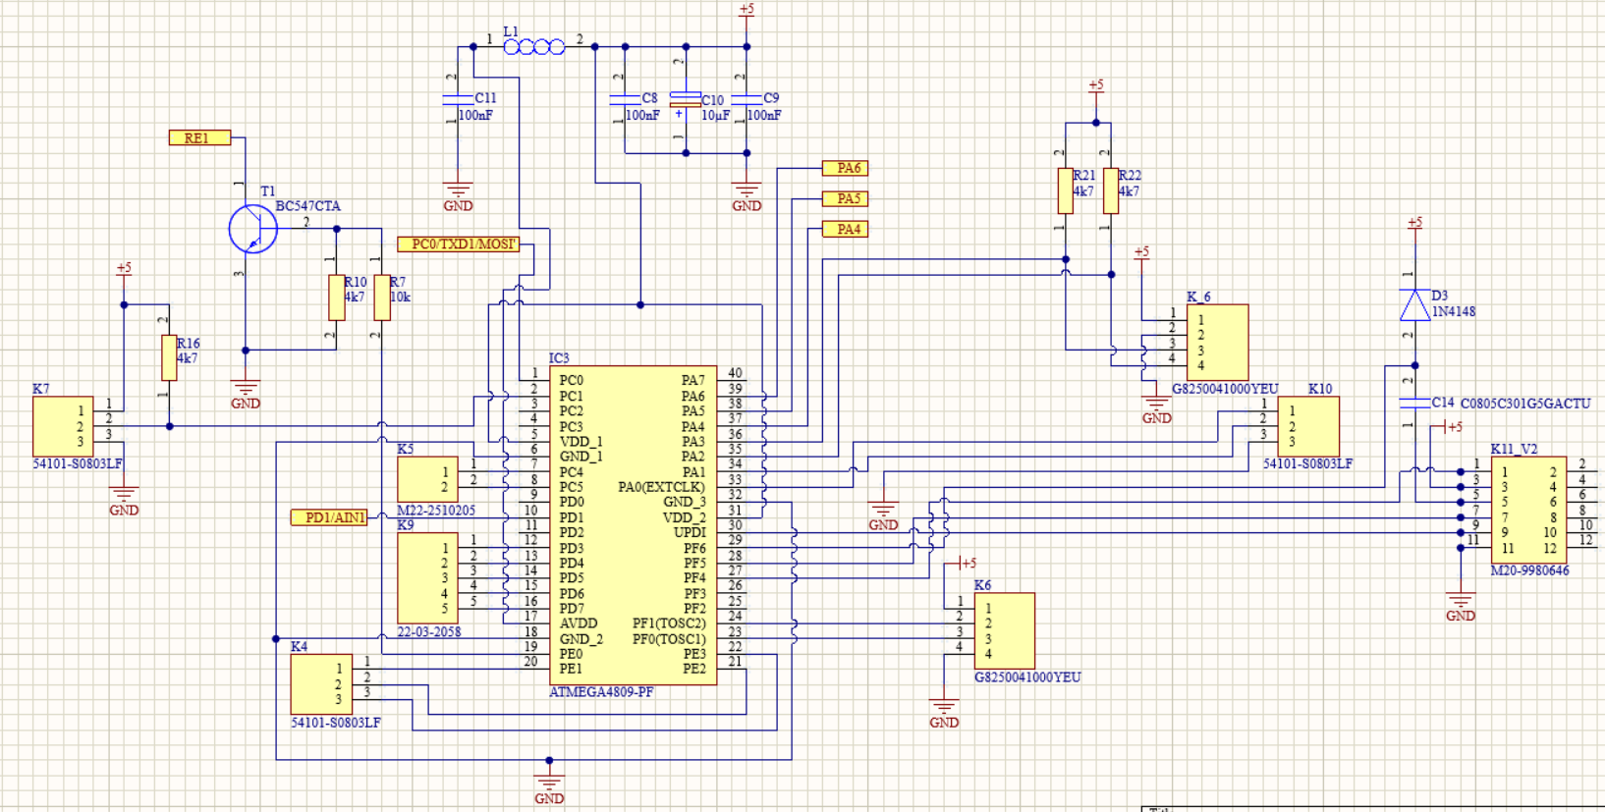

### How does it function?

The ATmega4809-PF is the brain of the whole soldering iron. This chip is a 8-bit microcontroller with Unified Program and Debug Interface. The ATmega is programmed with an Arduino UNO through command prompt on a computer. The type of soldering iron is set by software and the microcontroller selects the corresponding supply voltage and A/D converter input to measure the temperature of the tip. On this design are many pin-headers and print terminal blocks. These can be used to connect external components. As example there can be a DS18B20 1-Wire temperature sensor be connected to K7.

## Display

### Electrical schematic

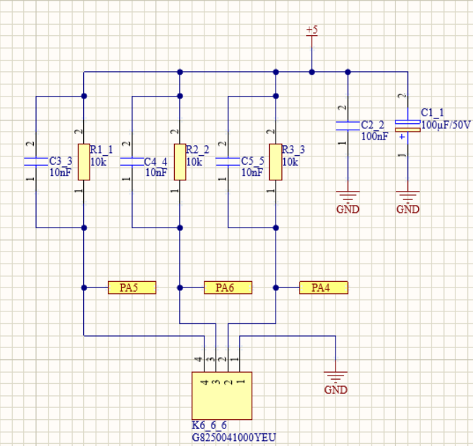

### How does it function?

This is a pullup circuit for the rotary encoder. When the signals of the rise- and fall time are shorter than the transit time along a trace or wire, the wave shape can be distorted. This arises if the impedance of the line does not match the source and receiver impedances by ringing. This problem is solved by putting a series of RC loads on the end that absorbs energy at the ringing frequency, the receiving end, without adding any DC load to the logic high or low level. When a low value resistor is inserted between the source and the line to slow the rise and fall times, it will also work. It is not common that a capacitor is used at either end. There is one exception for CMOS inputs that have a series resistor in the line. These are used to produce an effective delay between signal source and downstream gate.

## PCB design

## Finalized product

# Discussion

To start this project all the components of the list are needed. This is where the first things can cause some trouble. There are a few components from stock and therefore they cannot be ordered. There is a solution by buying another similar component with the same specs.

The electrical design and PCB are designed on Altium Designer. Make different sheets so all the schematics are uncluttered and that every wire is connected correctly. Watch out for wrong footprints downloaded from Mouser, there are some not right. Do some extra research to find the right ones!

Design the PCB on Altium Designer too. This is not difficult accept to make the gerber files. Ask for help if needed.

With the gerber files it is possible to order the PCB-print. Upload the files on JLCBCP and they make the prints based on the gerber files. When the prints come in the mail check the footprints again. If there are still some not right, solder some wires to the THT holes and solder the wires on the right pin of the component.

Design the case of the soldering iron in Fusion 360, search on internet for some explanation about how everything works. Search for how to make an assembly of my PCB, case and my case lid because it is hidden and not too simple to use.

While printing the case there are a few problems with the Prusa Mini, the 3D-printer on school. The black filling that is put in the 3D printer is a little bit too big or thin. Because of this the printer can randomly stop printing a few times and it gives an error. This is easy to fix by just pulling out the filling and re-inserting it a few times. After re-inserting the filling the 3D printer continues printing for a few hours until the filling is loose again. After a while the whole case is printed without any problems. The only thing these errors cause is that the case is not smooth everywhere but this does not affect the quality of the soldering iron itself.

# Reference list

|  |  |
| --- | --- |
| [1] | Elektor Magazine, „DHZ soldering station,” [Online]. Available: https://blackboard.pxl.be/ultra/courses/_33575_1/cl/outline. [Geopend 28 05 2022]. |